ICP2021 Assignment 1 part 2 report

Name: Christian Paul Domingo
Username: eeuc1c
Date prepared: 2 March 2012

Assignment 1 part2 – 1 code
clear all
clc
close all

%Assignment part 2 - 1
x = rand(1,200);
y = (x.*10) - 5;
x = y;

%create plot
plot(x,'k');
axis([0 200 -5 5]);
title('Signal');

Assignment 1 part2 – 2 code
clear all
clc
close all

%Assignment part 2 - 2
x = rand(1,200);
y = rand(1,200);

for i = 1:200
if(x(i) > y(i))
%blue triangles
plot(x(i),y(i),'^',...
'markersize', 10,...
'markeredgecolor','b');
hold on
elseif( y(1,i) > x(1,i))
%red stars
plot(x(i),y(i),'*',...
'markersize', 10,...
'markeredgecolor','r');
hold on
end
end

axis([0 1 0 1]);
title('Scatterplot');

Assignment 1 part2 – 3 code

clear all
clc
close all

%assignment 1 part 2 - 3

for x = 1:20
y = 1:20;
z = x;

r = rand; g = rand; b = rand;

%plot horizontal lines
plot([x,y],z,'s--',...
'MarkerEdgeColor',[r,g,b],...
'MarkerFaceColor',[r,g,b],...
'MarkerSize',20)
hold on
axis off
%plot vertical lines
plot(x,y,'s--',...
'MarkerEdgeColor',[r,g,b],...
'MarkerFaceColor',[r,g,b],...
'MarkerSize',20)
hold on

end

Assignment 1 part2 – 1 figure

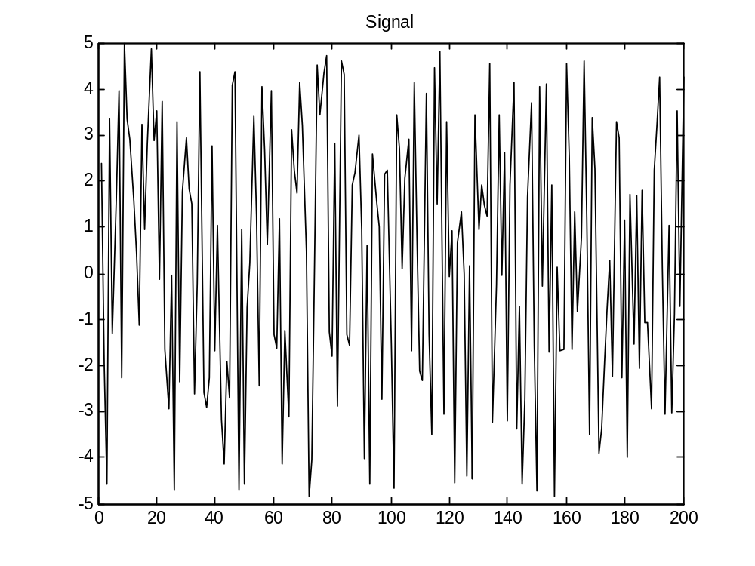
Assignment 2 part 2 – 2 figure
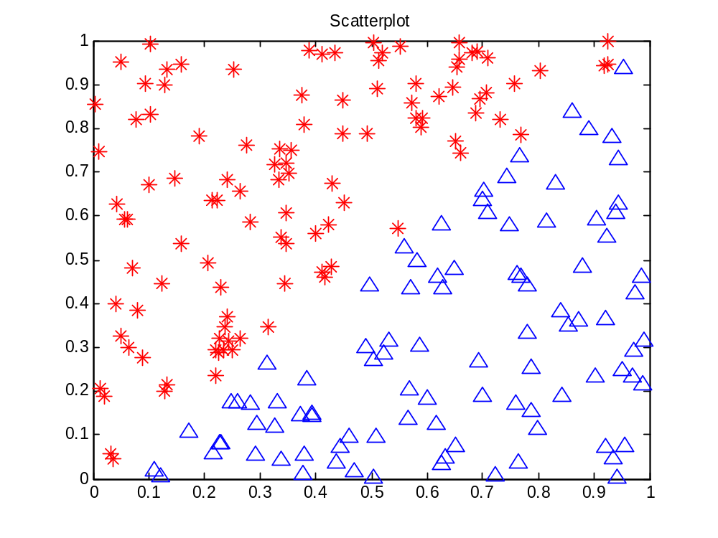
Assignment 2 part 2 – 3 figure



---- Put additional comments here ----

